Status of gender in media
"Taking into consideration that TV programs give information and reflect on gender roles in real life, it must be stated that women’s images are distorted and unrealistic in these programs. All kind of entertainment programs portray women in a dual image. On one hand, they are decorative objects. Yet, at the same time, they are passive individuals in the household and in marriage who are dependent on men for financial, emotional and physical support.”
GENDER:
Gender is when women and men are socialized for their roles that their cultures have prescribed them. Gender focuses on the socio-cultural elements of male and female role expectations. Gender role refers to sets of culturally defined character traits labeled as masculine and feminine.
GENDER EQUALITY:
Gender equality is when women and men have equal conditions for realizing their full human rights and potential to contribute to national, political, economic social and cultural development and benefit equally from the results.
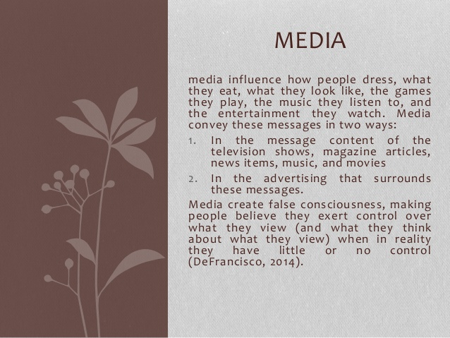
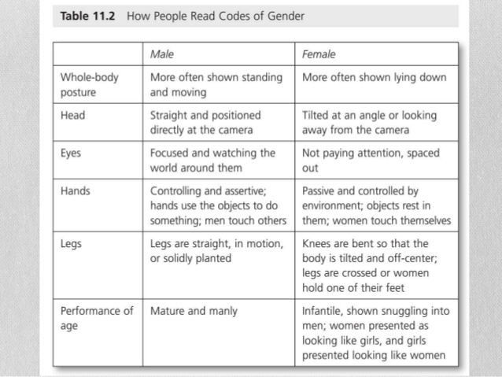
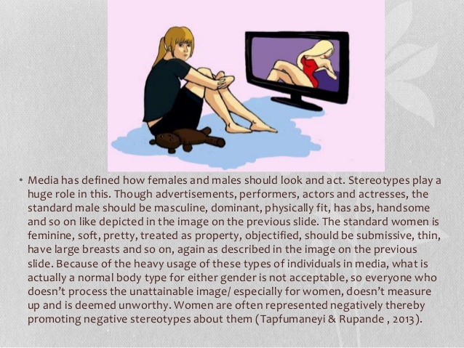
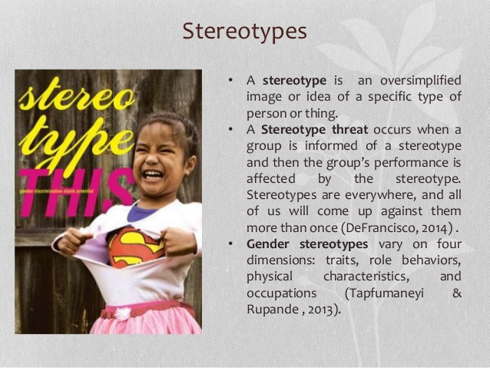
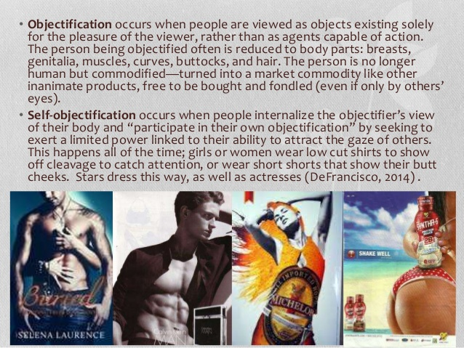
Mass media, however, continue to reproduce discriminatory stereotypes about women and portray them in sexist ways. As a rule, women are portrayed in a narrow range of characters in mass media. If we were to divide mass media into two categories, such as fictional and news-reporting, then in the former, women are often associated with the household or sex-objects, and in the latter category, they lack roles. Only in a limited number of news programs do women appear as main actors or experts. One of the reasons for this situation is the smaller number of women in these spheres, but even the existing number of women are underrepresented compared to their male counterparts. In advertising and magazines, women are usually portrayed as young, slim and with beauty that meets the accepted standards.Women with this kind of appearance are often associated with sex objects. Despite the fact that today media increasingly associate femininity with independent and powerful women, qualities informed by sexuality continue to play a dominant role in the shaping of femininity. Fragmental display of the female body and fragmentation of women’s body in advertisements promote the objectification of women’s bodies. When the TV screen or a commercial poster displays only slender long legs, prominent breasts or thighs, it is difficult to perceive that body holistically and as possessing personality.

